**Day 4 Assignment (07/12/2023) - Vamsi Viswanadham**

Worked on the below concepts.

* Using an Inner Join
* Using an Left Join
* Using an Right Join
* Using an Full Outer Join
* Using a Cross Join
* Joins with groupby,aggregate functions
* Using Date Functions
* Using Mathematical Functions
* Using System Functions
* Summarizing and Grouping Data
* Summarizing Data by Using Aggregate Functions

Here is a screenshot of the work.

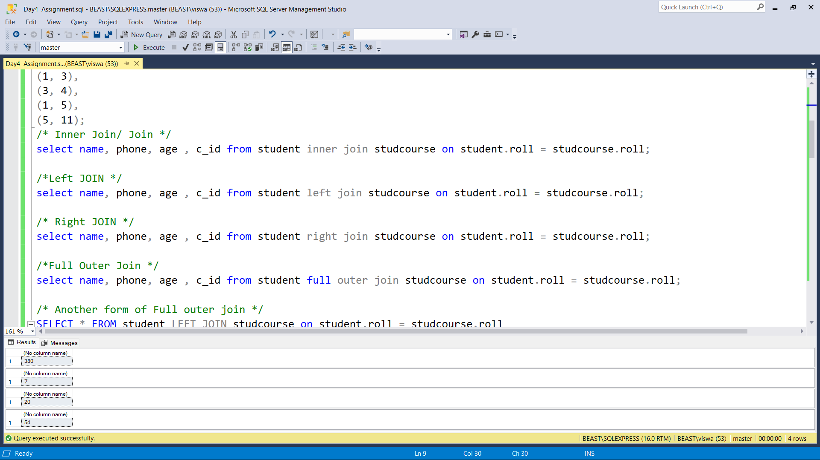

Here is a [SQL file](https://drive.google.com/file/d/1antvDqXtUSUfo7ApbGToRR-DwZCj8Ec0/view?usp=sharing) of the work.